Payroll Giving Authorisation Form

Your Contact Details
First Name:
Address:

Email address:

Surname:

Postcode:

Telephone Number:

Employer’s Details
Employer’s Name:
Employer’s Address:

Postcode:

Telephone Number:

Your Donation
I would like to support The Carers’ Centre work with a regular donation from my salary of:
☐ £10 (£8) ☐ £15 (£12) ☐ £20 (£16) ☐ £50 (£40) ☐ My choice £
The numbers in brackets represent the real cost to you (assuming a 20% tax rate) as the tax you would normally pay is donated to us.
Payment Frequency: ☐ Weekly ☐ Monthly
This donation is new / in addition to / supersedes my earlier instructions (please delete as appropriate)
Employee’s Payroll Number  Can be found on your payslip or your employer can provide it | National Insurance Number
Signature: | Date: | / | /

The personal information you provide will be held securely in accordance with our internal data protection policy and the Data Protection Act 1998. We do not share your details with third parties.

Payroll Giving
Payroll giving is a tax efficient scheme that lets you, as an employee, donate to your chosen charity/charities directly through your salary. The scheme allows for effortless regular donations through your salary, before tax is deducted, which makes your donation worth even more. Payroll Giving is a great way of donating and helps to provide charities, like The Carers’ Centre, with a regular income stream and gives employees a tax break on their donations.

Setting up Payroll Giving
To set up your Payroll Giving donations to The Carers’ Centre, just follow these simple steps:
- Complete and sign the form overleaf.
- Give the form to whoever is responsible for payroll within your organisation. Your Payroll or HR Team will forward this form to the Payroll Giving Agency (PGA) your employer uses. If your employer is not registered with a Payroll Giving Agency, please contact The Carers’ Centre and we can help to guide them through this process.
- Please also send a copy of the form to The Carers’ Centre, The Woodlands, Lower Bristol Road, Bath, BA2 9ES, or email a copy to finance@banescarerscentre.org.uk so we can thank you for your donations.

How your donation goes further
The real cost to you as an employee is much less than the amount you pledge to donate, as the tax you pay is also donated to the charity.

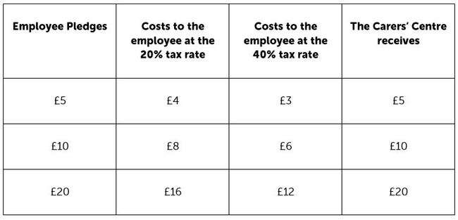

How your donation will make a difference
£10 each month could enable four young carers to access vital wellbeing support.
£20 could help us to deliver essential support to 12 carers in crisis.
£50 will help us keep the door of The Carers’ Centre open so we can continue to support the thousands of unpaid carers in Bath and North East Somerset.

Thank you for supporting The Carers’ Centre

