Candidate Information Pack

Board of Trustees

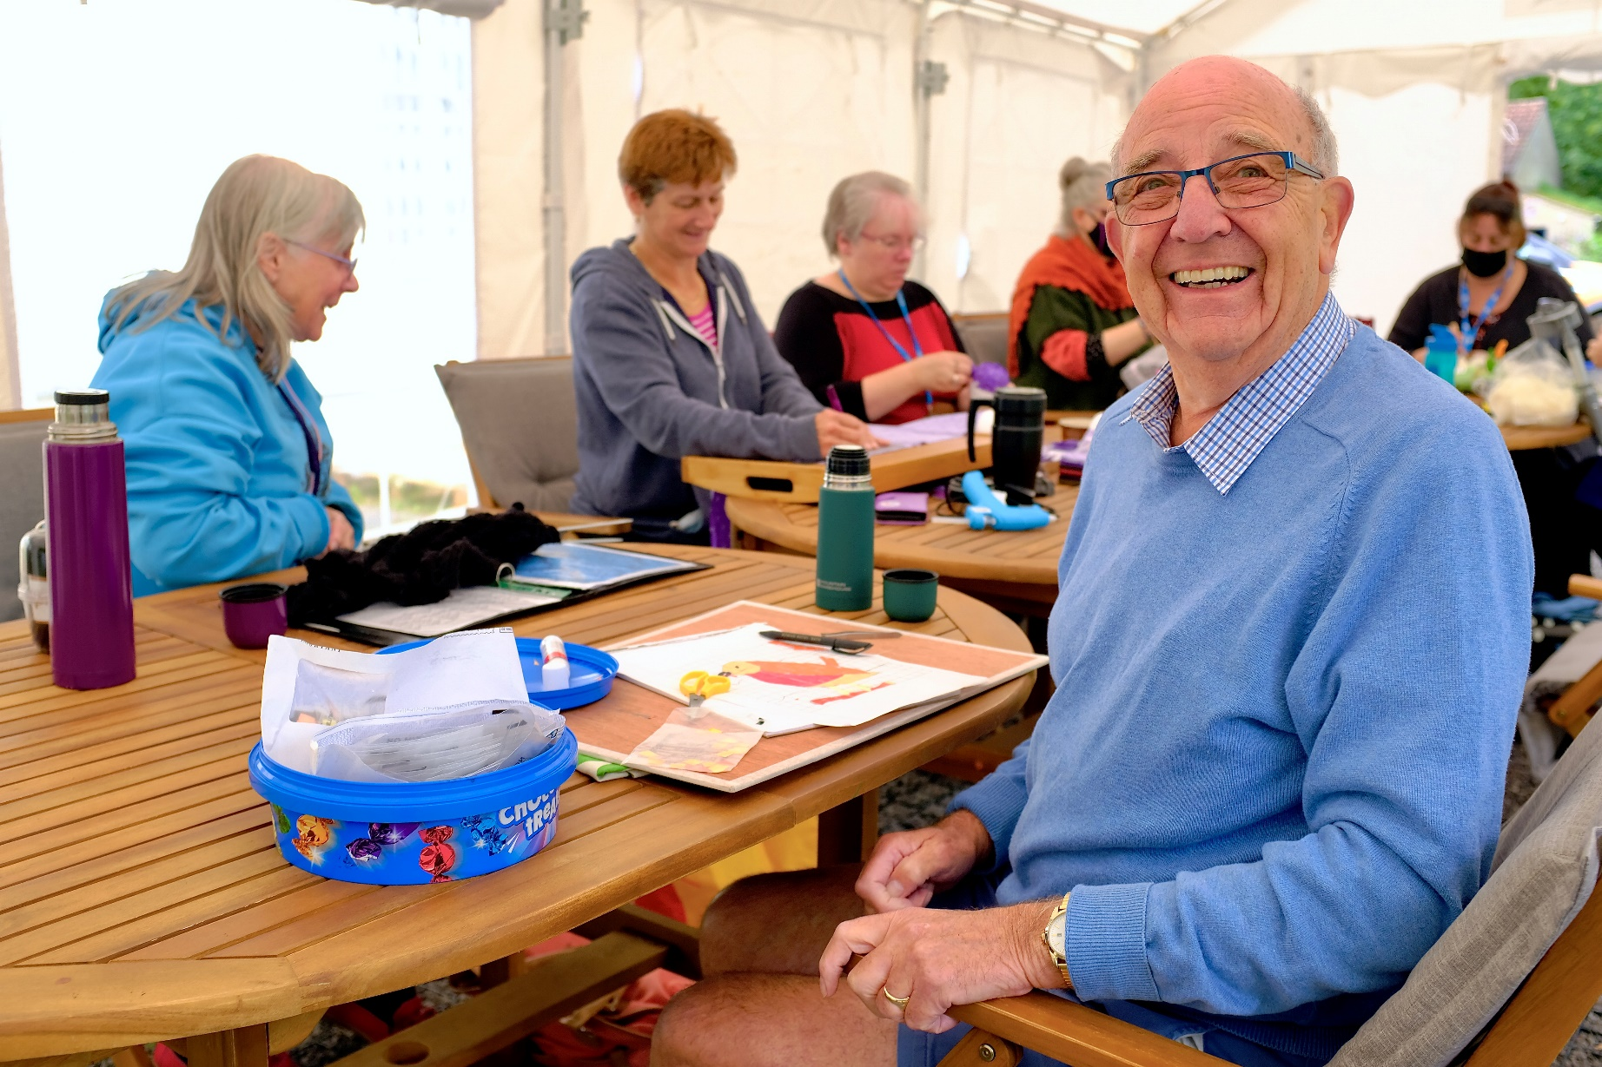

Contents

Our Values 6

Current Strategy 7

Our Services 8

Stay well 8

Stay in control 8

Stay connected 8

Young Carers 8

The Future 9

Organisational Structure 9

Trustees 9

The Carers’ Centre Organisational Chart 13

Trustee Role Description 14

Person Specification 15

Recruitment, Appointment, Support and Training 16

Recruitment Process 16

Chair of Trustees Introduction

It is a sobering realisation that two out of three people will become unpaid carers in the near future or become the cared for. Few of us will escape; unpaid carers will become everybody’s business in our lives.

In its 28th year, The Carers’ Centre’s work is to support unpaid carers and we help both adults and young carers in achieving our vision of a community where unpaid carers of today and tomorrow are fully recognised, valued, and supported.

We support almost 6,000 of the estimated 25,000 unpaid carers that are in local authority district of Bath and North East Somerset through a variety of services. These include wellbeing activities, carer cafés, peer support groups, a freephone support line, and activities tailored to young carers. One of our key priorities going forward is to extend our reach to support more carers within Bath and North East Somerset as statutory services continue to rely on their invaluable support to meet the increasing health and care needs of many individuals within our communities.

At The Carers’ Centre, we are not waiting for the future and so we are continuing the transformation to a data informed and digitally empowered organisation to reach more unpaid carers. One way we are doing this is via a project to reach far into communities that surround unpaid carers to identify and support them.

As we do this work within our organisation it prepares us well to engage within the wider new world of Integrated Care Systems, where the voice of unpaid carers must be heard. Our CEO, Jacqui Orchard will continue to work with our Board of Trustees, staff and volunteers to take us forward on this journey by helping to develop our next strategy, continuing to build on our robust financial position, improving our services, ensuring our voice is heard through the networks of our communities, and building our presence clearly in the new commissioning world.

We are keen to now progress the appointment of a new treasurer for The Carers’ Centre; this person will need to recognise the culture of our organisation and its values and bring their enthusiasm and passion to the role.

I thank you for your interest in this role and welcome your application if you feel you would like to make a difference to the lives of unpaid carers.

**Frank Mowat, Chair of Trustees**

Chief Executive Officer Introduction

It is an exciting and challenging time to join The Carers’ Centre. Trustees and staff have carefully and emphatically navigated the many challenges of the current economic environment and health care transformation programme to continue delivering services that are timely, accessible, and meaningful to both young and adult unpaid carers. As we move forward, the voice of unpaid carers will remain at the heart of all that we do.

We have a unique asset at The Carers' Centre premises, it is a grade 2 listed building with access to the river, its own gardens and parking which is used for both office and meeting space for unpaid carers and groups. Whilst our continued digital innovation is a critical and essential part of our development plan to raise awareness, provide accessible information 24/7 and increase capacity, there will always be a need for face-to-face interaction alongside this. We are currently looking at developing a longer-term strategy for the building and gardens which will help to maximise its impact for unpaid carers.

Diversifying our income streams is a significant priority area to ensure that we have the resources to respond to emerging needs, the impact of changes to the Care Act and the anticipated increase of unpaid carers from 20,000 (ONS 2021) to 30,000 in 2030 (Carers UK) in Bath and North East Somerset. We have recently appointed a Development Manager to lead on income diversification activities.

Finally, innovative collaboration with partners locally and regionally will need to be a strong focus in the years ahead to ensure that the voices of unpaid carers are heard, and we are able to harness the opportunities that will arise through the evolving integrated care agenda.

**Jacqui Orchard, Chief Executive Officer**

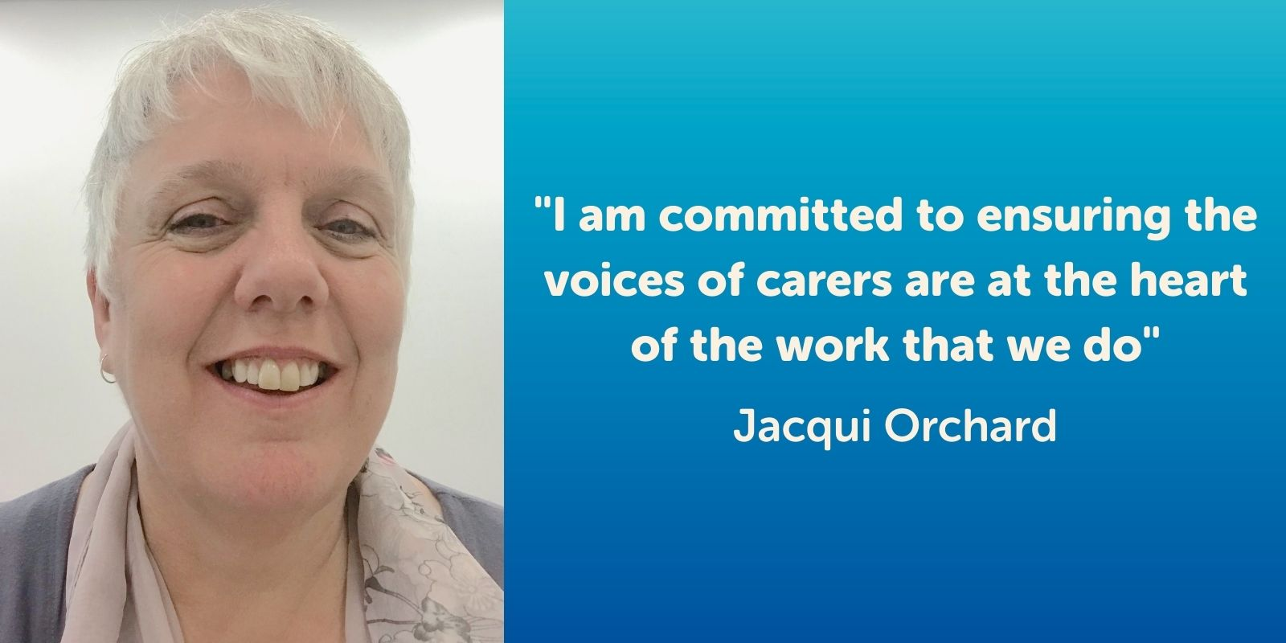

About The Carers' Centre

The origins of The Carers’ Centre date back to 1986 at the Volunteer Bureau, which provided volunteering opportunities across the Radstock area. In 1994 a carers’ support project began, and by 1999 this had become the sole purpose of the organisation, as national and local legislation began to formally recognise family carers. In December 1996, The Care Network became a company limited by guarantee and was later accepted as a member of the Princess Royal Trust for Carers (now Carers Trust) in 2005. Since 2010 we have been known as The Carers’ Centre and, as a local independent charity, remain a network partner of Carers Trust.

We have 25 years’ experience of supporting unpaid carers of all ages. We use the term ‘unpaid carer’ to describe anyone who cares, without payment, for a friend or family member who due to illness, disability, a mental health problem or an addiction cannot cope without their support.

There are an estimated 25,000 unpaid carers aged from five upwards living in Bath and North East Somerset. In the past 12 months our 25-strong staff team, supported by dedicated volunteers, have supported around 5,000 adult carers and 850 young carers.

Financially we are a small to medium sized charity with an annual turnover of about £800k. Around two thirds of our funding comes from local authority contracts, which are in place until 2025 and 2031. The remaining income comes from various grants and donations. We have recently appointed a Development Manager to diversify our income streams and increase our unrestricted income.

[**Read our Impact Report**](https://banescarerscentre.org.uk/about-us/our-impact/) to find out more.

The garden at The Carers' Centre, The Woodlands, Bath, BA2 9ES

# Our Values

|  |  |
| --- | --- |
| **Honest** | We are truthful and sincere in all we do for carers. |
| **Fair** | We treat everyone we work with equally and with respect. |
| **Supportive** | We provide encouragement and help to all we work with. |
| **Empowering** | We make carers stronger and more confident, especially in controlling their life and claiming their rights. |
| **Innovative** | We seek to find new and creative ways to achieve our mission. |
| **Sustainable** | We work to ensure we will always be here to support carers, by considering financial, social, and environmental concerns in our decision-making. |



# Current Strategy

Our vision is to create a community where unpaid carers of today and tomorrow are fully recognised, valued, and supported with what they need to keep well, stay in control, and feel connected.

Our mission is to provide trusted information, advice, and support to carers of all ages enabling them to maintain or improve their health and wellbeing as well as take control of their caring role and stay connected with others. In addition, we work with our wider community to improve recognition and support for unpaid carers.

Our current strategic aims are that:

* Unpaid carers have improved physical health and emotional wellbeing.
* Unpaid carers are better able to manage the impact of caring.
* Unpaid carers are better able to have a life alongside of caring.
* People living in Bath and North East Somerset understand the needs of local unpaid carers.
* We are a sustainable organisation in charge of our own destiny.

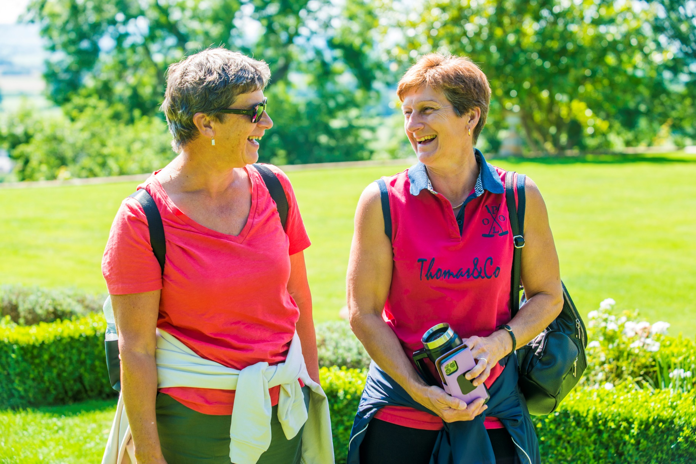

# Our Services

We meet these aims through our services. These enable us to support carers to:

## Stay well

Through a programme of group wellbeing activities to encourage carers to take the space to breathe, recharge and stay well, all in the company of others who understand.

## Stay in control

By providing access to free, impartial, and trusted information, advice, and guidance. We listen and help carers understand what they need to do now, next and for the future.

## Stay connected

By running local pop-up neighbourhood carer cafés and peer support groups across Bath and North East Somerset.

# Young Carers

For young carers, we provide a space for these amazing young people to have fun and make friends with other young carers.

“To everyone at The Carers’ Centre who has helped and supported me over the past 10 years - thank you for doing what you do. I really can’t put into words how grateful I am. You have changed my life so much for the better.”

“Just talking to you made me feel better.   
I now have the prospect of opportunities,   
it's now up to me to take action. So much better than the feeling of helplessness I had before our conversation.”

“I feel a weight has been lifted from my shoulders”

“'The Carers’ Centre are brilliant.   
You've always helped us whenever we've had any questions.”

# The Future

We are currently developing a new strategy for the years ahead.

In doing so, we will need to take into account the opportunities and challenges presented, among other things, by the following:

Our commitment to ongoing digital innovation to help develop more social infrastructure, supported, and connected through a platform of digital services, products, and new content. This in turn will increase our reach from the 6,000 carers we currently serve, to the significantly larger proportion of the 25,000 across the region. Our focus has moved from solely providing direct services for carers, to unlocking, supporting, and strengthening informal support systems that exist around carers in communities across the UK.

The significant changes in commissioning structures within the NHS that have led to the implementation of the Integrated Care System and the local and regional health care priorities.

The legacy impact of Covid in health and financial terms placing increasing financial pressures on local authorities and the Integrated Care System.

The social and demographic changes that are taking place over the next 10 years.

# Organisational Structure

## Trustees

As a charity, The Carers’ Centre is governed by a Board of Trustees, which is ultimately accountable for all that we do. It is an experienced and skilled team, drawn from a variety of backgrounds, and is bringing energy and direction to our work. The Board is integral to and accountable for deciding our strategy, ensuring financial viability and probity, adhering to the terms of our governing document, and delivering to our beneficiaries the outcomes we have determined from our strategy.

In addition to our Trustees meeting as a full Board, we have three sub-groups covering finances, people, and service provision. Each group is made up of staff representatives and Trustees. The sub-group’s function is to speed up decision making. They report to the full Board and enable more involvement for the Trustees in the governance of the organisation.

We currently have seven Trustees, who are listed below. **Click on their name for more details.**

[Frank Mowat - Chair](https://banescarerscentre.org.uk/about-us/who-we-are/frank-mowat/)

**Appointed April 2022**

[**Jenny Theed (Vice-Chair)**](https://banescarerscentre.org.uk/about-us/who-we-are/jenny-theed/)

**Appointed February 2014**

[Ken Littlewood (Interim Treasurer)](https://banescarerscentre.org.uk/about-us/who-we-are/ken-littlewood/)

**Appointed November 2019**

[Christine Bone](https://banescarerscentre.org.uk/about-us/who-we-are/christine-bone/)

**Appointed January 2014**

[Barry Hulme](https://banescarerscentre.org.uk/about-us/who-we-are/barry-hulme/)

**Appointed October 2017**

[Paul Richards](https://banescarerscentre.org.uk/about-us/who-we-are/paul-richards/)

**Appointed November 2019**

[Joanna Hole](https://banescarerscentre.org.uk/about-us/who-we-are/joanna-hole/)

**Appointed June 2022**

# 

# The Carers’ Centre Organisational Chart

# Trustee Role Description

**Reporting to:** The Chair of Trustees (also known as the Board).

**Purpose**

The main purpose of the role is to maintain an overview of the organisation’s affairs, ensuring its financial viability, compliance with our charitable objects, company, and charity law and the maintenance of proper financial records and procedures.

The Trustee’s role is to:

* Ensuring that The Carers’ Centre pursues its stated objects (purposes), as defined in its governing document, by developing and agreeing a long-term strategy.
* Ensuring that the organisation complies with its governing document, (its memorandum and articles of association), charity law, company law and any other relevant legislation or regulations.
* Ensuring that the organisation applies its resources exclusively in pursuance of its charitable objects (i.e. the charity must not spend money on activities that are not included in its own objects, however worthwhile or charitable those activities are) for the benefit of the public.
* Ensuring that the organisation defines its goals and evaluates performance against agreed targets.
* Safeguarding the good name and values of the organisation.
* Ensuring the effective and efficient administration of the organisation, including having appropriate policies and procedures in place.
* Ensuring the financial stability of the organisation.
* Protecting and managing the property of the charity and ensuring the proper investment of the charity’s funds.
* Following proper and formal arrangements for the appointment, supervision, support, appraisal, and remuneration of the Chief Executive.

Trustees are jointly responsible for all The Carers’ Centre activities including matters delegated to staff and sub-groups. They are bound by the majority decision of fellow Trustees. Responsibility is never delegated.

Treasurer Role Description

In addition to the general responsibilities of a Trustee, duties of the treasurer include the following.

* Overseeing, approving, and presenting budgets, accounts, and financial statements.
* Being assured that the financial resources of the organisation meet its present and future needs.
* Ensuring that the charity has an appropriate reserve policy.
* Preparing and presenting financial reports to the board.
* Ensuring that appropriate accounting procedures and controls are in place.
* Liaising with staff about financial matters.
* Advising on the financial implications of the organisation’s strategic plans.
* Ensuring that the charity has an appropriate investment policy.
* Ensuring that there is no conflict between any investment held and the aims and objects of the charity.
* Monitoring the organisation’s investment activity and ensuring it is consistent with the organisation’s policies and legal responsibilities.
* Ensuring that the accounts are prepared and disclosed in the form required by funders and the relevant statutory bodies, for example the Charity Commission and/or the Registrar of Companies / SORP.
* Ensuring that the accounts are scrutinised in the manner required (independent examination or audit) and any recommendations are implemented.
* Keeping the board informed about its financial duties and responsibilities.
* Contributing to the income generation strategy of the organisation.
* Making a formal presentation of the accounts at the annual general meeting and drawing attention to important points in a coherent and easily understandable way.
* Sitting on appraisal, recruitment and disciplinary panels as required.

The overriding duty is to act in good faith and in the belief that what you are doing is correct and to act prudently and reasonably in all matters. This means that you need to know about legal, financial, and managerial issues affecting The Carers’ Centre. You are not expected to have expert knowledge in these areas but are expected to seek advice where the expertise is needed. In short, the Charity Commission expects you to behave as a “Person of Prudence” and document as much.

Key behaviours expected from Trustees:

* Take an active part in the strategic management the organisation.
* Act at all times in the best interest of the organisation and its beneficiaries.
* Avoid a conflict of interest.
* Not profit from Trusteeship.
* Use The Carers’ Centre assets exclusively to pursue its aims.
* Attend the required number of Board Meetings.
* Uphold the ethical standards and culture of the organisation in all it does.

# Person Specification

General requirements

* A commitment to the organisation.
* A willingness to devote the necessary time and effort.
* Strategic vision.
* Good, independent judgement.
* An ability to think creatively.
* A willingness to speak their mind.
* An understanding and acceptance of the legal duties, responsibilities, and liabilities of Trusteeship.
* An ability to work effectively as a member of a team.
* A commitment to Nolan’s seven principles of public life: selflessness, integrity, objectivity, accountability, openness, honesty, and leadership.

In addition to the person specification for a Trustee, the treasurer should have the following qualities:

* Financial qualifications and/or experience.
* Some experience of charity finance, fundraising and pension schemes.
* The skills to analyse proposals and examine their financial consequences.
* Being prepared to make unpopular recommendations to the Board.
* A willingness to be available to finance staff for advice and enquiries on an ad hoc basis.

# Recruitment, Appointment, Support and Training

We have a recruitment and appointment process for Trustees.

We take up references and adhere to the Charity Commission guidance on Trustee appointments. There are some standard disqualifications as given below.

Appointments are initially for three years but in most cases are renewed if desired. They are made by ordinary resolution at our AGM or by a Trustee Board resolution if the timing is better. All Trustee roles are voluntary but reasonable expenses will be paid.

We are enthusiastic about our Board governance. Trustee training, appraisal and opportunities for personal development are all important to us.

There is no doubt that the Trustee role requires commitment and that this can bring meaningful rewards.

## Recruitment Process

**Stage 1**

An informal discussion and information-sharing meeting is arranged. This is an opportunity to meet with the CEO and/or Chair of The Carers’ Centre and talk about:

* The Carers’ Centre services and the environment it works in.
* What you may have to offer.
* The role and responsibilities of Trustees and more specifically the Treasurer role.
* Experience and skills needed for the Treasurer.
* What The Carers’ Centre can provide.
* Any questions you may have.

At this point we can send you a Trustee Application Pack.

**Stage 2**

* A completed application form is returned.
* If satisfactory, an invitation to come and observe a Board meeting will be extended.
* A chance to see more of how the charity works if desired is warmly welcomed.

**Stage 3**

* An interview with some Trustees will then be arranged.
* If it is agreed on both sides that the applicant will become The Carers’ Centre Treasurer, this recommendation will be confirmed at the next committee meeting subject to obtaining satisfactory references and a DBS check.

**Stage 4**

* The appointment will be confirmed at the AGM or by a Resolution of the Trustees as interim so that the appointment is active.
* A Trustee induction will be carried out and the completed Directors/Trustee form sent off to Companies House.

**Stage 5**

The induction will include:

* Roles and responsibilities.
* Governance and management.
* The Carers’ Centre policies and guidelines.
* Staffing and personnel.
* Funding and financial reporting.
* Trustees’ information pack.

**Stage 6**

* Ongoing support and training.
* External Trustee training.
* Board meeting training.
* Away days.
* Resources and reminders.
* Appraisal and personal development focus.

Disqualifications

There are some circumstances by which some people are disqualified from acting as charity Trustees or nominees, including anyone described in Section 72(1) of the 1993 Act. This includes:

* Anyone who has been convicted of an offence involving deception or dishonesty unless the conviction is spent.
* Anyone who is an undischarged bankrupt.
* Anyone who has been previously removed from Trusteeship of a charity by the Court or Commission for misconduct or mismanagement.
* Anyone who is under a disqualification order under the Company Directors Disqualification Act 1986.

You will need to complete a declaration when submitting your application form.

For further information click on the link and contact [Jacqui Orchard](mailto:Jacqui.Orchard@banescarerscentre.org.uk), The Carers’ Centre CEO.